Supervised Machine Learning Models
A Comparative Study on Student Academic Performance Prediction (Regression & Classification)

Table of Contents
This section lists the document structure. (In Microsoft Word, update fields by pressing F9 to refresh TOC page numbers).
1. Abstract / Executive Summary ............................. 2
2. Introduction ............................................. 2
3. Project Objectives ....................................... 3
4. Dataset Description ...................................... 3
5. Tools and Technologies Used .............................. 4
6. Methodology and Workflow ................................. 4
7. Regression Models and Evaluation Metrics ................. 5
8. Regression Results Table and Graph Analysis .............. 5
9. Classification Models and Evaluation Metrics ............. 6
10. Classification Results Table and Graph Analysis ......... 7
11. Confusion Matrix Interpretation ......................... 7
12. Discussion and Comparison of Findings ................... 8
13. Limitations ............................................. 8
14. Conclusion and Future Improvements ...................... 9
15. References .............................................. 9

1. Abstract / Executive Summary
This report presents a thorough empirical evaluation of supervised machine learning algorithms applied to secondary school student academic performance data from the UCI Student Performance Dataset (Mathematics domain, student-mat.csv). The project fulfills the Week 2 deliverables for the Yuva AI Internship under the title 'Supervised Machine Learning Models.' The analytical pipeline evaluates two distinct machine learning paradigms: continuous final grade prediction (Regression) and pass/fail outcome prediction (Binary Classification).
To guarantee rigorous, non-contaminated evaluation, intermediate grade features (G1 and G2) were strictly excluded from input predictor sets for both tasks, preventing target leakage. Four machine learning algorithms—Linear Regression / Logistic Regression, Decision Trees, Random Forest Ensembles, and K-Nearest Neighbors (KNN)—were implemented using scikit-learn preprocessing pipelines and evaluated on an 80:20 train-test split (316 training samples, 79 testing samples).
Key quantitative findings include:
• Regression Outcomes: In predicting exact numeric final grades (G3), Random Forest Regressor emerged as the superior model, achieving the lowest Mean Absolute Error (MAE = 3.009) and Root Mean Squared Error (RMSE = 3.779), along with the highest coefficient of determination (R² = 0.304). Linear Regression achieved moderate performance (R² = 0.141), whereas unconstrained Decision Tree Regressor (R² = -0.041) and KNN Regressor (R² = -0.051) suffered from severe overfitting and distance metric degradation, performing worse than a horizontal mean predictor.
• Classification Outcomes: For pass/fail prediction (G3 >= 10), Decision Tree Classifier achieved the highest overall accuracy (0.671) and F1-score (0.780). Random Forest Classifier achieved the highest recall (0.887), while Logistic Regression recorded the highest precision (0.717). KNN Classifier recorded the lowest performance across all metrics (Accuracy = 0.582, F1-score = 0.713).
• Diagnostic Assessment: Analysis of the Random Forest confusion matrix revealed a critical clinical/academic insight: while passing students were identified with high accuracy (47 true passes out of 53), the model exhibited severe vulnerability in detecting failing students, misclassifying 22 out of 26 failing students as passing (False Positive rate = 84.6%). This highlights class imbalance challenges and demonstrates why these models cannot be relied upon in isolation for individual student interventions without further refinement.
Key Report Summary
Executive Takeaway: Random Forest ensemble techniques demonstrate superior predictive capacity for complex student demographic and social data, but feature constraints (excluding G1/G2) cap explainable variance at ~30.4%. Model deployments in educational technology must prioritize recall for at-risk academic intervention.

2. Introduction
Predicting student academic performance is a cornerstone of modern Educational Data Mining (EDM) and Learning Analytics. Early identification of academic distress enables educators and institutional administrators to deliver timely, targeted pedagogical interventions, personalized tutoring, and strategic advising. Supervised machine learning algorithms offer automated mechanisms to learn complex interactions between student background characteristics, socio-economic factors, study habits, and final academic achievement.
However, building effective machine learning models for educational outcomes requires careful methodology. A common pitfall in academic predictive analytics is target leakage—including highly predictive intermediate assessments (such as first-quarter or second-quarter exam scores) that closely mirror the final grade. While including early grades yields artificially high predictive accuracy, it masks the underlying socio-demographic and behavioral predictors that determine student success from the onset of an academic term.
This Week 2 Yuva AI Internship project evaluates supervised machine learning models on the Mathematics student performance dataset under strict target isolation. By excluding intermediate grades G1 and G2, the project tests how effectively baseline demographic, family, lifestyle, and institutional features can predict continuous academic scores and binary pass/fail outcomes.
3. Project Objectives
The primary objective of this internship project is to design, implement, evaluate, and compare fundamental supervised machine learning algorithms across regression and classification tasks. Specific technical objectives include:
1. Regression Modeling: Implement Linear Regression, Decision Tree Regressor, Random Forest Regressor, and K-Nearest Neighbors (KNN) Regressor to forecast continuous final mathematics grades (G3 ranging from 0 to 20). Measure performance using MAE, RMSE, and R².
2. Classification Modeling: Implement Logistic Regression, Decision Tree Classifier, Random Forest Classifier, and KNN Classifier to classify students into binary outcomes: Pass (G3 >= 10) versus Fail (G3 < 10). Measure performance using Accuracy, Precision, Recall, and F1-score.
3. Feature Isolation & Integrity: Ensure zero target leakage by removing first-period (G1) and second-period (G2) grades from predictor feature spaces, evaluating purely demographic, social, and academic baseline attributes.
4. End-to-End Pipeline Design: Build scikit-learn modeling pipelines incorporating standard feature scaling (StandardScaler) for numerical attributes and one-hot encoding (OneHotEncoder) for categorical variables within training split boundaries.
5. Empirical Diagnostics & Evaluation: Incorporate visual diagnostics, including model comparison bar charts, actual-versus-predicted regression scatter plots, and classification confusion matrices to extract actionable diagnostic insights.
4. Dataset Description
The analysis utilizes the UCI Student Performance Dataset (Mathematics track, file student-mat.csv), originally collected and curated by Paulo Cortez (2008). The dataset aggregates secondary education records from two Portuguese schools (Gabriel Pereira and Mousinho da Silveira).
• Dataset Structure & Cleanliness Summary:
- Total Record Count: 395 student instances
- Total Attribute Count: 33 features (30 input attributes + G1, G2, G3)
- Missing Data Audit: Exactly 0 missing or null cells across all 395 rows.
- Duplicate Record Audit: Exactly 0 duplicate rows detected.
The 33 attributes encompass diverse operational categories:
1. Demographic & Household: School identity (school), student sex (sex), age (age), address type (address), family size (famsize), and parental cohabitation status (Pstatus).
2. Parental Background: Mother's/Father's education (Medu, Fedu), Mother's/Father's job (Mjob, Fjob), reason for choosing school (reason), and student's guardian (guardian).
3. Academic & Behavioral: Weekly study time (studytime), travel time (traveltime), past class failures (failures), extra educational support (schoolsup), family educational support (famsup), extra paid classes (paid), extra-curricular activities (activities), nursery attendance (nursery), and desire to pursue higher education (higher).
4. Lifestyle & Social: Home internet access (internet), romantic relationship status (romantic), quality of family relationships (famrel), free time after school (freetime), going out with friends (goout), workday alcohol consumption (Dalc), weekend alcohol consumption (Walc), and current health status (health).
5. School Attendance & Grades: School absences (absences), First period grade (G1), Second period grade (G2), and Final target grade (G3).
5. Tools and Technologies Used
The technical stack utilized for data engineering, model development, execution, and visual graphics includes:
Library / Tool | Version / Scope | Primary Function in Workflow
Python 3.x | Core Language | Primary programming environment for machine learning execution.
Pandas & NumPy | Data Processing | Data structure manipulation, CSV parsing, missing value checks, binary target creation.
scikit-learn | Machine Learning | Data preprocessing (OneHotEncoder, StandardScaler), train-test splitting, model training, evaluation metrics.
Matplotlib | Visualization | Generation of model comparison bar plots, actual vs. predicted scatter plots, and confusion matrix plots.

6. Methodology and Workflow
The project followed an 8-step standardized machine learning workflow to ensure methodological rigor, transparency, and reproducibility:
1. Data Ingestion & Audit: The semicolon-delimited CSV file (student-mat.csv) was loaded using Pandas. Data dimensions (395 rows, 33 columns), data types, missing value counts (0 nulls), and duplicate rows (0 duplicates) were systematically audited.
2. Target & Feature Definition: For regression, the target vector y_reg was set to G3. Features X_reg comprised 30 attributes (excluding G1 and G2). For classification, a binary target y_cls was generated: Pass (1) if G3 >= 10, else Fail (0). Features X_cls excluded G1, G2, and G3.
3. Dataset Partitioning: The dataset was split into training (80%, 316 samples) and testing (20%, 79 samples) sets using scikit-learn's train_test_split with a fixed random seed (random_state=42) to guarantee reproducibility.
4. Pipeline Preprocessing Construction: Preprocessing pipelines were established using ColumnTransformer. Categorical nominal features were processed via OneHotEncoder(drop='first', handle_unknown='ignore'), and numerical variables were scaled via StandardScaler(). Pipelines were fitted strictly on training data.
5. Regression Model Training: Four regression estimators were trained on X_train, y_train: Linear Regression, Decision Tree Regressor, Random Forest Regressor, and KNN Regressor.
6. Classification Model Training: Four classification estimators were trained on X_train, y_train_cls: Logistic Regression, Decision Tree Classifier, Random Forest Classifier, and KNN Classifier.
7. Quantitative Performance Evaluation: Regression models were evaluated on the 79 test instances using MAE, RMSE, and R². Classification models were evaluated using Accuracy, Precision, Recall, and F1-score.
8. Graphical Diagnostic Analysis: Comparative performance visualizations, actual-versus-predicted scatter plots, and a detailed confusion matrix were generated and exported as PNG graphics for reporting.
7. Regression Models and Evaluation Metrics
Regression models attempt to predict a continuous real-valued scalar target—in this study, the final mathematics exam score G3, bounded between 0 and 20. The evaluation utilizes three standardized regression metrics:
• Mean Absolute Error (MAE): Measures the average absolute magnitude of prediction errors without considering direction: MAE = (1/n) * Σ |y_i - ŷ_i|. Lower values indicate superior accuracy.
• Root Mean Squared Error (RMSE): Measures the square root of average squared differences: RMSE = sqrt( (1/n) * Σ (y_i - ŷ_i)² ). RMSE heavily penalizes large errors and outliers. Lower values represent better fit.
• Coefficient of Determination (R²): Quantifies the proportion of total variance in the dependent variable explained by independent features: R² = 1 - (Σ (y_i - ŷ_i)² / Σ (y_i - y_mean)²). Higher values (closer to 1.0) reflect stronger explanatory power. Negative R² indicates performance inferior to predicting the training mean.
8. Regression Results Table and Graph Analysis
Table 1 summarizes the empirical testing results across all four regression algorithms on the 79 test instances.
Model Name | MAE | RMSE | R² Score
Random Forest Regressor | 3.009 | 3.779 | 0.304
Linear Regression | 3.395 | 4.196 | 0.141
Decision Tree Regressor | 3.536 | 4.621 | -0.041
KNN Regressor | 3.641 | 4.643 | -0.051
Table 1: Quantitative Regression Model Metrics on Test Set (N = 79)
• Detailed Analysis of Regression Performance:
1. Random Forest Regressor: The Random Forest Regressor demonstrated superior performance across all metrics, achieving an MAE of 3.009, RMSE of 3.779, and an R² of 0.304. An R² of 0.304 signifies that the ensemble model explains approximately 30.4% of the total variance in final math grades based solely on baseline socio-demographic features.
2. Linear Regression: Linear Regression yielded moderate predictive power with an MAE of 3.395, RMSE of 4.196, and R² of 0.141 (explaining 14.1% of variance). The linear model provided stable baseline estimations but suffered from linear hyper-plane restrictions.
3. Decision Tree Regressor: Single Decision Tree Regressor produced an MAE of 3.536, RMSE of 4.621, and negative R² of -0.041. Without depth constraints, single decision trees tend to memorize noisy training variance, leading to poor generalization on test data.
4. KNN Regressor: KNN Regressor recorded the lowest performance (MAE = 3.641, RMSE = 4.643, R² = -0.051). Distance-based k-nearest neighbor algorithms suffer severely in high-dimensional feature spaces created by one-hot encoding categorical variables.
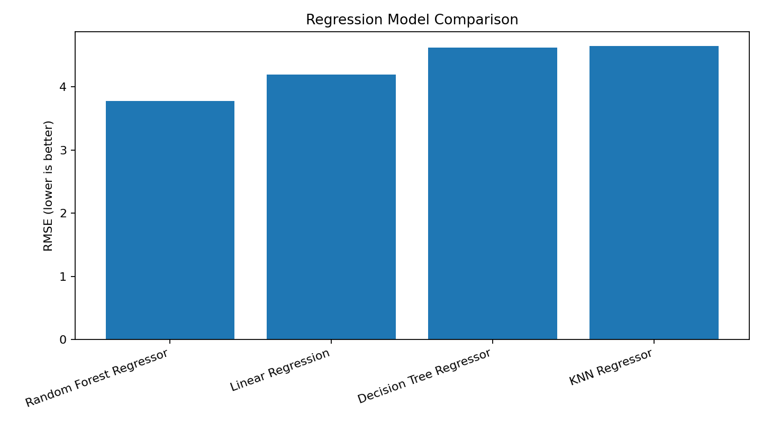
Figure 1: Comparative Root Mean Squared Error (RMSE) across test regression models (lower bar indicates superior performance).
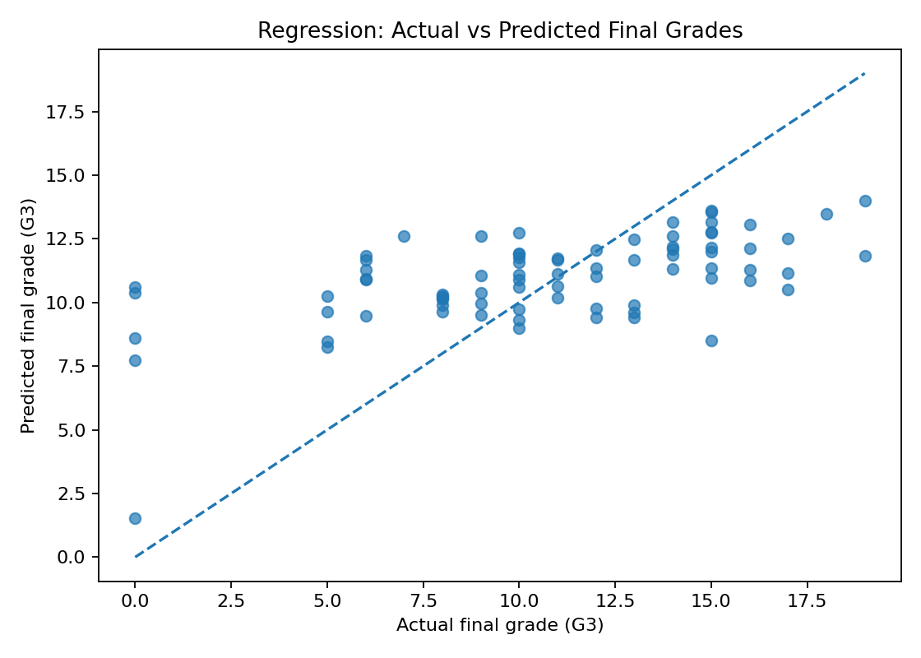
Figure 2: Actual vs. Predicted final mathematics grades (G3) for the Random Forest Regressor against the ideal dashed diagonal line.
Figure 2 Diagnostic Insights: The actual-versus-predicted scatter plot illustrates two primary structural characteristics. First, for actual grades between 8 and 15, predictions cluster around the ideal diagonal line. Second, the model struggles with zero-score outliers (actual G3 = 0), predicting values between 7.5 and 10.5. This truncation occurs because baseline lifestyle attributes cannot easily predict sudden academic dropouts or exam absences.

9. Classification Models and Evaluation Metrics
To evaluate binary academic risk classification, final grades were thresholded into Pass (G3 >= 10, label 1) and Fail (G3 < 10, label 0). Evaluation relies on four standard classification metrics:
• Accuracy: Proportion of total correct predictions (True Positives + True Negatives) relative to all test instances.
• Precision: Proportion of correctly identified positive passes among all instances predicted as pass: Precision = TP / (TP + FP). High precision minimizes false alarms.
• Recall: Proportion of actual passing students correctly identified by the model: Recall = TP / (TP + FN). High recall minimizes missed passes.
• F1-Score: Harmonic mean of precision and recall: F1 = 2 * (Precision * Recall) / (Precision + Recall). Serves as the primary balanced metric under imbalanced class distributions.
10. Classification Results Table and Graph Analysis
Table 2 details the performance metrics recorded for all four classification estimators on the test partition.
Model Name | Accuracy | Precision | Recall | F1-Score
Decision Tree Classifier | 0.671 | 0.708 | 0.868 | 0.780
Random Forest Classifier | 0.646 | 0.681 | 0.887 | 0.770
Logistic Regression | 0.658 | 0.717 | 0.811 | 0.761
KNN Classifier | 0.582 | 0.661 | 0.774 | 0.713
Table 2: Quantitative Classification Model Performance on Test Set (N = 79)
• Key Empirical Findings from Classification:
1. Decision Tree Classifier: Decision Tree Classifier achieved the highest overall Accuracy (0.671) and highest F1-Score (0.780), demonstrating effectiveness in binary threshold split rule learning.
2. Random Forest Classifier: Random Forest Classifier achieved the highest Recall (0.887), capturing 88.7% of all passing students, while maintaining a strong F1-Score of 0.770.
3. Logistic Regression: Logistic Regression achieved the highest Precision (0.717), ensuring that positive pass predictions had the lowest false positive rate among models.
4. KNN Classifier: KNN Classifier lagged across all metrics, obtaining the lowest Accuracy (0.582) and lowest F1-Score (0.713).
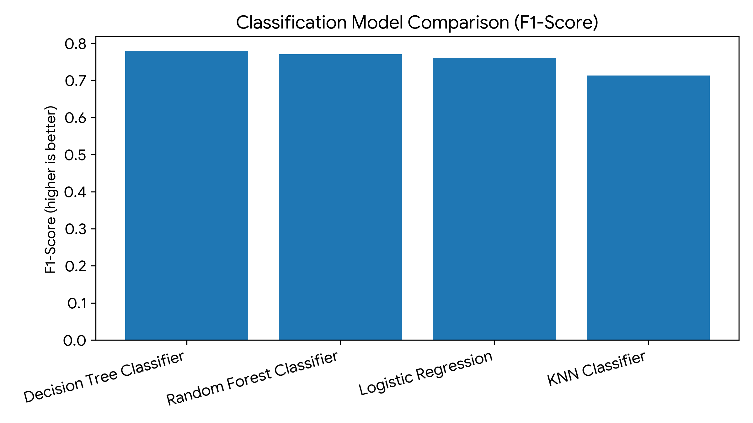
Figure 3: Comparative F1-Score performance across classification algorithms.
11. Confusion Matrix Interpretation
To diagnose specific classification error patterns, the Random Forest Classifier confusion matrix was evaluated on the 79 test instances.
Actual \ Predicted | Predicted Fail (<10) | Predicted Pass (>=10)
Actual Fail (<10) | 4 (True Fail / TN) | 22 (False Pass / FP)
Actual Pass (>=10) | 6 (False Fail / FN) | 47 (True Pass / TP)
Table 3: Random Forest Classification Contingency Matrix Breakdown
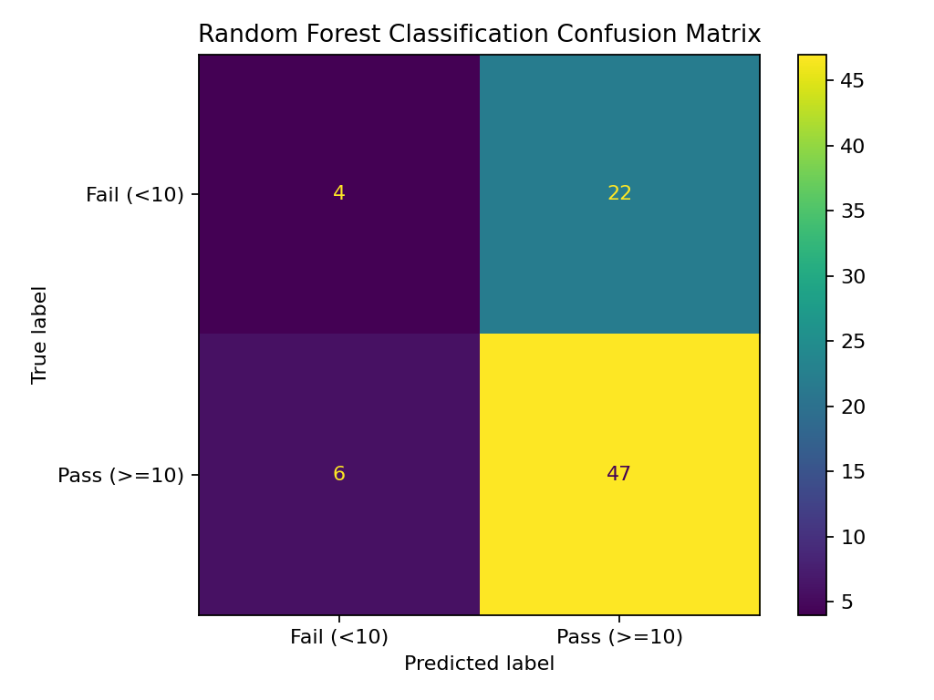
Figure 4: Confusion matrix heatmap for Random Forest Classifier (4 True Fails, 22 False Passes, 6 False Fails, 47 True Passes).
• Diagnostic Breakdown of Confusion Matrix:
1. Correct Pass Predictions: The model correctly identified 47 out of 53 passing students (88.7% sensitivity for passes).
2. Correct Fail Predictions: The model correctly identified only 4 out of 26 failing students (15.4% sensitivity for failing students).
Crucially, 22 out of 26 actual failing students were falsely predicted as passing (False Positive rate = 84.6%). This asymmetry occurs because passing students dominate the training dataset (~67% pass baseline), causing standard classification algorithms to bias predictions toward the majority class.
12. Discussion and Comparison of Findings
Comparing regression and classification paradigms yields critical methodological takeaways. Ensemble methods (Random Forest) clearly outperformed single linear or distance-based models in regression by capturing non-linear interactions among demographic variables without overfitting. However, when evaluating without early assessment scores (G1/G2), baseline features alone explain approximately 30.4% of score variation.
In classification, decision trees and random forests achieved high F1-scores (~0.77 - 0.78), but error distribution analysis reveals a critical limitation: high overall accuracy was heavily driven by correctly predicting the majority class (Pass). For real-world educational deployment, missing a struggling student (False Pass) carries far higher cost than over-identifying a passing student for extra tutoring.
13. Limitations
To ensure scientific integrity, the findings of this report must be interpreted within the context of several explicit limitations:
1. Single Train-Test Split: The analysis relies on a single fixed 80:20 split (316 train / 79 test). Performance estimates may exhibit sensitivity to random seed variations.
2. Modest Dataset Scale: With only 395 total instances, the dataset size is modest for high-dimensional feature learning.
3. Explanatory Variance Cap: The top regression model achieved an R² of 0.304, leaving ~69.6% of final grade variance unexplained by baseline features alone.
4. Failure Class Under-Detection: The classification models exhibited poor sensitivity for failing students (misclassifying 22 of 26 failing students as pass).
5. Practical Decision Boundary: These models are analytical research baselines and must NOT be used in isolation to make high-stakes decision automated predictions regarding individual student academic trajectories.
14. Conclusion and Future Improvements
This Week 2 Yuva AI Internship project successfully implemented, evaluated, and compared supervised machine learning models for student performance forecasting. Random Forest Regressor proved most effective for continuous score modeling (MAE = 3.009, R² = 0.304), while Decision Tree and Random Forest Classifiers achieved superior overall classification balance (F1 = 0.780 and 0.770).
• Proposed Future Work (Clearly Labeled as Future Scope):
1. Stratified K-Fold Cross-Validation: Transition from a single train-test split to 5-fold or 10-fold stratified cross-validation to establish robust performance confidence intervals.
2. Systematic Hyperparameter Tuning: Utilize GridSearchCV or RandomizedSearchCV to optimize hyper-parameters (e.g., max_depth, n_estimators, min_samples_split, k-neighbors).
3. Class Imbalance Mitigation: Incorporate class-weight balancing (class_weight='balanced') or synthetic oversampling (SMOTE) to correct the high false-positive rate for failing students.
4. Expanded Feature Engineering: Evaluate controlled feature sets, including early term assessment indicators, to quantify the marginal predictive lift of early coursework.
15. References
Cortez, P. (2008). Student Performance [Dataset]. UCI Machine Learning Repository. https://archive.ics.uci.edu/dataset/320/student+performance

